ANNOUNCEMENTS

-The Garden Project is well on the way. On March 25, 2024, at 9:00 a.m., construction of the first vegetable beds began. Various committee members and guest/volunteers participated.
-Presbyterian Women Dues It’s time to pay your 2024 dues for the Presbyterian Women Organization. Good news – our annual dues are still just $60. Please pay your dues today. If you cannot pay the full amount at one time, paying in installments makes it easier.

Month | Payment Amount
March | $15.00
April | 15.00
May | 15.00
June | 15.00
Grand Total | $60.00
Payments should be given to your Circle Leader with checks made payable to Statesville Avenue Presbyterian Church. Thanks to those who have already paid!
-One Great Hour of Sharing Offerings ended today.
-Per Capita of $30.00 per year per member.
-Treasurer Offerings online: Here’s another way to give: www.statesvilleavenuepresbyterianchurchusa.org
-Presbyterian Women’s Spring Gathering will be held at Marks Creek Presbyterian Church (USA), April 6, 2024, (484 Marks Creek Church Road, Hamlet, NC 28345) Registration: 9:00-9:45 A.M. and Program starts at 10:00 a.m. All ladies are urged to attend!
-Installation of Church Officers for the Class of 2026 will be held on Sunday, April 14, 2024, during worship service.
-Session Meeting, April 17, 2024, at 5:00 p.m. in the Fellowship Hall.
-Visitors, thank you for choosing to worship with us today, we look forward to fellowshipping with you again. To all, stay safe, God Bless!!!

“Dear God, our world is torn with war and violence. We pray that you provide your creation with a peace that is only found in you. Amen.”

STATESVILLE AVENUE PRESBYTERIAN CHURCH (USA)
3435 NEVIN ROAD, CHARLOTTE, NC 28269
March 31, 2024
11:00 A.M.

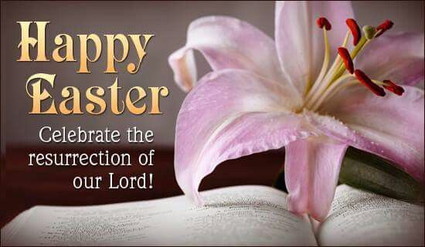

Gary S. Blackmon, Pastor
Harriett Davis, Liturgist
Mr. James Rogers, Jr., Director of Music
704-596-4550

www.statesvilleavenuepresbyterianchurchusa.org

We Gather

**Prelude: “”Total Praise”

Announcements and Welcome:

Lighting of Candles:

**Introit: “Behold the Lamb” -Behold the Lamb, behold the Lamb, slain from the foundation of the world. For sinners crucified. O Holy sacrifice, behold the Lamb of God, behold the Lamb.

* Call to worship:

L: Christ is Risen! Shout Hosanna!
P: Hosanna! Hosanna!
L: Celebrate this day of days!
P: Hosanna! Hosanna!
L: Let all creation be amazed!
P: Hosanna! Hosanna! Christ is Risen!

*Centering Prayer:
**Opening Hymn: “Jesus Christ Is Risen Today!” #123
Prayer of confession: Savior God, forgive our life-alienating ways, our exclusion and judgment of others; the way we evaluate and compare. Forgive our habits that demean and degrade, our addiction to violent and destructive behavior. Redeem us. Restoring us. Resurrect us for life in Christ. Amen.

Assurance of pardon: Jesus Christ is risen today. But the pains which he endured; our salvation have procured.

In the name of Jesus Christ, we are forgiven. Alleluia. Amen.

** Special Selection: (On Monitor)

Prayer for Illumination: Divine redeemer, bearer of life, open us to the wisdom of your Word today and enlighten us with your truth. Liberate us from all that distracts us and turns us from your path. Guide us and ground us in Christ’s everlasting hope. Amen.

The Word

Scripture Reading: Isaiah 25:6-9

Sermon: John 20:1-18
“The Miracle of Easter”

We Respond

Invitation to Discipleship: “Jesus Purchased My Salvation”

Prayers for the People:

Choral Response: “Thank You for Hearing Our Prayer!”

Affirmation of faith (Book of Common Worship): This is the good news which we have received, in which we stand, and by which we are saved, if we hold it fast: that Christ died for our sins according to the scriptures, that he was buried, that he was raised on the third day, and that he appeared first to the women, then to Peter, and the Twelve, and then to many faithful witnesses. We believe that Jesus is the Christ, the Son of the living God. Jesus Christ is the first and the last, the beginning and the end; he is our Lord and our God. Amen.

Tithes and Offerings: “Because He Lives”

*Doxology: “Glory Be to the Father” #579

Prayer of Thanksgiving:

Celebration Song: “Christ Arose”

*Charge and Benediction:

Extinguishing of the Candles:

Postlude: “He Is Lord”/Passing the Peace

*Please stand if you are able.
**Worshippers may enter or exit.

